Deep Learning
- What is Deep Learning?

. 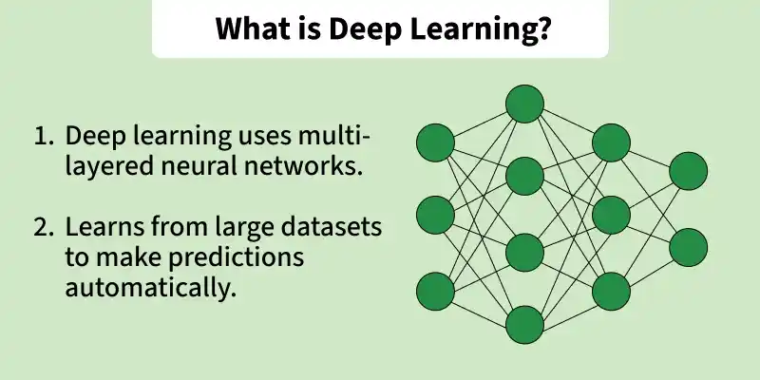

Subset of ML
Deep Learning is a part of Machine Learning

Part of AI
Machine Learning itself is a branch of Artificial Intelligence (AI)

Inspired by Human Brain
Uses Artificial Neural Networks (ANNs) similar to brain structure

Multi-layered Networks
Has many hidden layers → that’s why called “Deep”

Automatic Learning
Learns features automatically (no manual feature engineering needed)

Works with Big Data
Needs large amounts of data to perform well

Learns Complex Patterns
Can understand complicated relationships in data

In simple words, Deep learning tries to mimic the structure of the human brain. It uses multi-layered neural networks (hidden layers) to learn patterns from data and make predictions.

- Why we learn Deep Learning?
- No manual feature engineering needed
→ Automatically learns useful features from raw data
- Domain knowledge
→ Less domain knowledge needed
- Performs better with large datasets
→ Deep learning is data-hungry
- Captures complex patterns
→ Works well for high-dimensional & complex data
- High accuracy in complex tasks
→ Especially in image, speech, and text problems
- End-to-end learning
→ Takes raw input → directly gives output (less pipeline work)
- Works well with unstructured data
→ Images, audio, video, text (not just tables)
- Scalable with hardware (GPU/TPU)
→ Can train faster with modern hardware
- State-of-the-art results
→ Used in cutting-edge systems (AI assistants, recommendation systems, etc.)
We learn deep learning because it can automatically extract features, handle large and complex data, and achieve high accuracy. It works especially well with unstructured data like images, text, and audio, and can learn end-to-end patterns without heavy manual effort.

When to Use Deep Learning?
- Large Dataset Available
→ Deep learning performs best with huge amounts of data

- Complex Problem
→ When relationships in data are complicated
→ Example: image recognition, speech, NLP

- Unstructured Data
→ Works great with:
  - Images
  - Text
  - Audio
  - Video
- High Accuracy Needed
→ When performance matters more than simplicity

- Automatic Feature Learning Required
→ No need to manually create features

- Sufficient Computational Power
→ GPU/TPU to train models

- End-to-End Learning Needed
→ Input → directly output (no complex pipeline)

Real-Life Examples
- Face recognition
- Voice assistants
- Chatbots
- Self-driving cars
Deep learning is best used when we have large amounts of data, complex patterns, and unstructured data, along with enough computational power to train models effectively.

When NOT to Use Deep Learning?
- Small Dataset
→ Deep learning needs a lot of data
→ With small data, simple models (like Logistic Regression) work better
- Limited Computational Power
→ Requires GPU/TPU
→ If low resources → training becomes slow & expensive
- Need for Interpretability
→ Deep learning = black box model
→ Hard to explain decisions (important in medical/finance fields)
- Simple Problem
→ If problem is easy → no need deep learning
→ Traditional ML models are faster & efficient
- Time Constraints
→ Training takes a lot of time
→ Not suitable for quick solutions
- Lack of Data Quality
→ Garbage data = bad performance
→ Needs clean & well-prepared data
Deep learning is powerful, but it is not always the best choice. For small datasets, limited resources, or when interpretability is required, traditional machine learning models are more suitable.

Why Deep Learning is Better?
- Architecture (Many Hidden Layers)
→ Deep learning uses multi-layered neural networks
→ Each layer learns progressively complex patterns
- Data Representation (Automatic Feature Learning)
→ Automatically extracts useful features from raw data
→ Reduces manual feature engineering and human effort
- Non-linear Pattern Recognition
→ Can model highly complex, non-linear relationships in data
→ Works better than traditional ML for complicated tasks
Deep learning, with its multi-layered architecture, automatically learns useful features and captures complex non-linear patterns, making it more powerful for large and complicated datasets.

Core Components of Deep Learning

1. Inputs / Neurons
- Interconnected units that perform mathematical operations
- Receive input → apply activation function → produce output
- Similar to brain neurons

2. Weights and Biases
- Main learnable parameters of the network
- Weights decide importance of inputs
- Bias helps shift the output value
- Updated during training to reduce error

3. Hidden Layers
- Layers between input layer and output layer
- Extract patterns and important features from data
- More hidden layers = deeper learning
- Helps model learn complex relationships

4. Activation Function
- Decides whether a neuron should activate or not
- Adds non-linearity so the model can learn complex patterns
- Common activation functions:
  - ReLU
  - Sigmoid
  - Tanh
  - Softmax
Examples:
- ReLU → Fast and widely used (0,max)
- Sigmoid → Output between 0 and 1
- Softmax → Used for multi-class classification

5. Loss Function
- Measures how wrong the model’s prediction is .
- Lower loss = better prediction
- Examples:
  - Mean Squared Error (MSE)
  - Cross Entropy Loss

6. Optimizer
- Updates weights and biases to minimize loss
- Helps the model learn efficiently
- Common optimizers:
  - Gradient Descent
  - Adam
  - RMSProp
Neurons process data, weights/biases learn from it, hidden layers capture complex patterns.

Deep Learning Use-Cases
- Recommender Systems
  - YouTube video recommendations
  - Netflix movie/series recommendations
  - Amazon product recommendations
- Natural Language Processing (NLP)
  - Google Translate
  - Transformer-based models (BERT, GPT)
  - Chatbots, text summarization
- Computer Vision (CV)
  - Image recognition & classification
  - Object detection & segmentation
  - Self-driving cars backbone
- Sequence Modeling
  - Time series prediction
  - Sequence-to-sequence models (translation, speech
DL is used in recommender systems, NLP (Transformers), computer vision, and sequence modeling like time series.

- Linearly vs Non – linearly separatable dataset
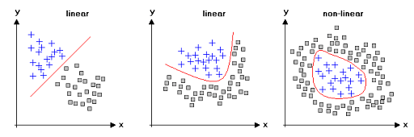
Non-linear

Linear vs Non-Linear Data
Linear Data
Linear data is data that can be represented or separated using a straight line (in 2D) or a hyperplane (in higher dimensions).
Characteristics: Single straight line can separate the data.

Non-linear Data
Definition:
Non-linear data cannot be represented or separated by a straight line. The relationship between variables is curved or complex.
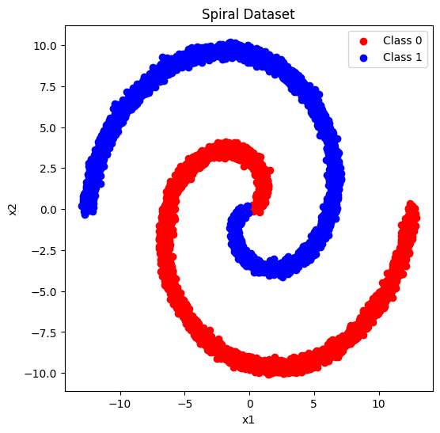
Examples:
- XOR problem
- Circular or spiral patterns
- Image and speech data
Characteristics:
- Complex relationships
- No single straight line can separate the data
- Requires more powerful models like:
  - Deep Learning (Neural Networks)

Key Difference

Linear data → Straight line works → Simple pattern

Non-linear data → Curve/complex boundary needed → Complex pattern

